

**Project Title:**

# Harvel Electric

|  |  |
| --- | --- |
| Project Title | Mentor |
| Harvel Electric | Sir Sheheryar |

**Acknowledgment**

**We are Thankful to ALMIGHTY ALLAH that by HIS Grace we have been successful and we are presenting this project. We have tried our best to take all relevant and necessary topics into our consideration so that this project may become comprehensive.**

**This is our 1st Semester. We have strived for a better outlook to come. This project has been developed using the Microsoft Visual Code software We have been assigned to make a website named Cambridge Hospital as per the requirements of our CPISM Project. We tried to observe the coding and its layout on Visual Studio. We found it easy to utilize the editor.**

**Additionally, we would like to thank our faculty and our mentor Sir Sheheyar for his esteemed guidance throughout the creation of this project.**

**We would also express our sincere gratitude to the E-Project team from APTECH CLIFTON CENTER, for their valuable guidance and support for the completion of this project.**

**We earnestly hope that this project will provide all the necessary information required by the user to fulfill his/her inspiration.**

**However, your suggestions and feedback for improvements are going to be thankfully welcomed &amp; acknowledged.**

**Thank You**

**Problem Statement**

Harvel Electric is selling various electrical products. The company advertises by distributing the pamphlets, advertising on television and so on. Due to rapid development in internet field, the company decides to launch a website where people will get all the information about the various products available with them easily.

**Website Designing Requirements:**

The Web site is to be created based on the following requirements.

1. The Home Page should be created making use of Sections with a suitable logo
2. The site should display a menu which will contain the options for brief introduction about the various products available, location of the shop and any other information if required.
3. The information should be categorized according to different type of products like if a User wants to see only ‘FANS’ then he click on a Link/button/menu etc and he will see different type of FANS. Similarly for ‘GEYSERS’, ‘CFL’ and other products
4. When a user selects any product type, a list of products for that product type will be displayed.
5. A brief summary of features of individual products should be displayed on the Web Page along with the product but detailed Features should be stored in Individual Word documents which can be downloaded or viewed by the User who wishes to see the same.
6. Price List should be available for download.
7. There should be a “Contact Us” page which will have the Address of the Company which is as follows and the mail address which when clicked will invoke the local mail client from where they can send an email.

**Hardware/ Software Requirements**

**Hardware**

* A minimum computer system that will help you access all the tools in the courses is a Pentium 166 or better
* 64 Megabytes of RAM or better

**Software *[Either or Combination as per Course/Sem]***

* Notepad/HTML editor/CoffeeCup
* Angular / Angular JS / React / BootStrap
* Dreamweaver / Figma
* MS IE / Chrome / FireFox / Netscape /MS Edge

"Snippets from our website"

Home:

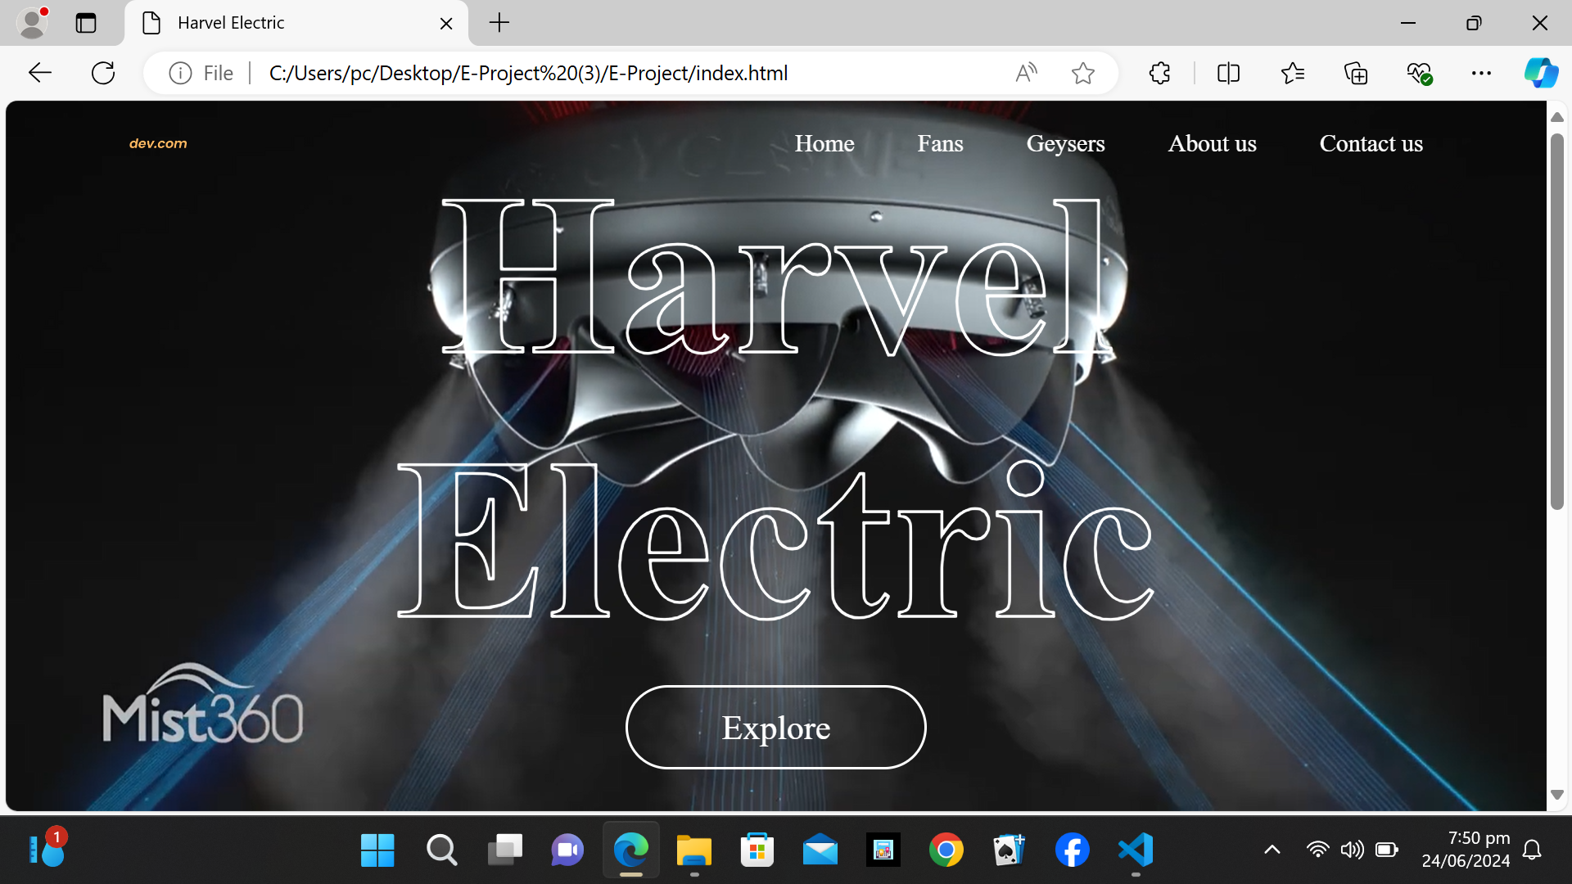

Fans:

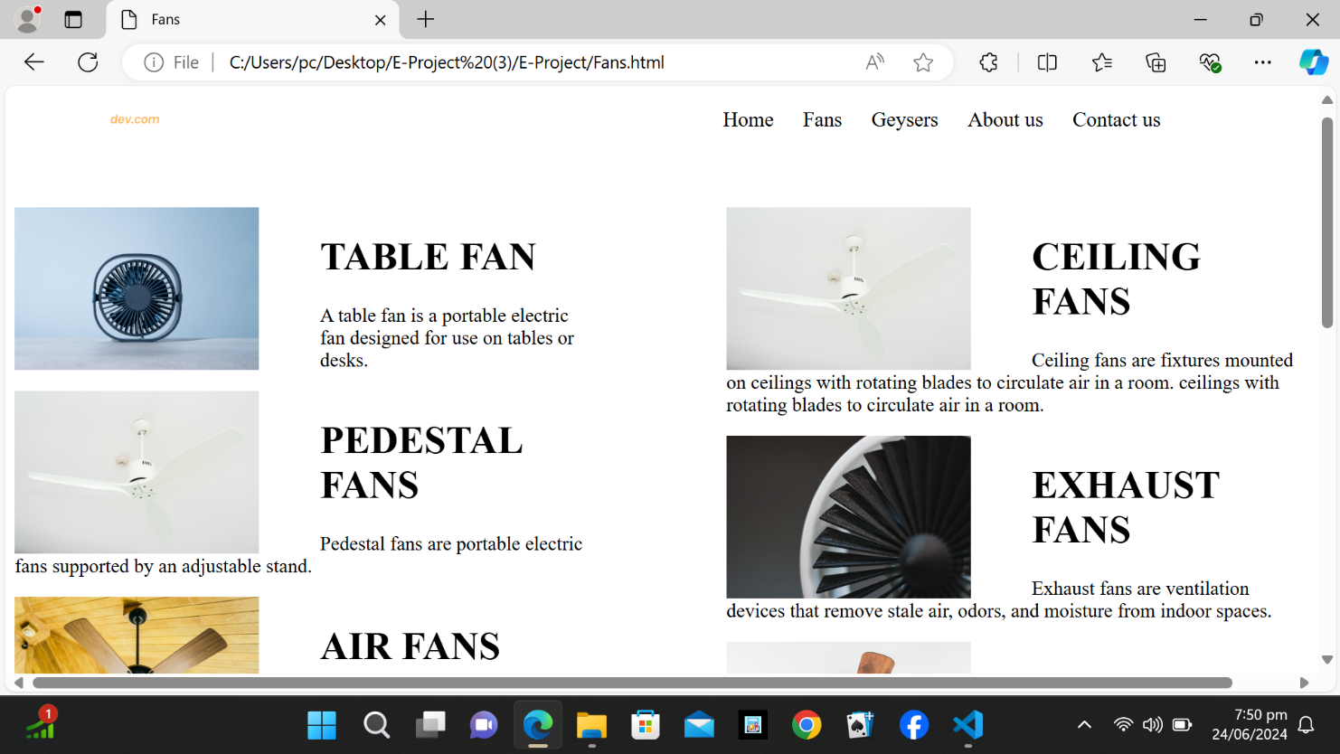

Footer

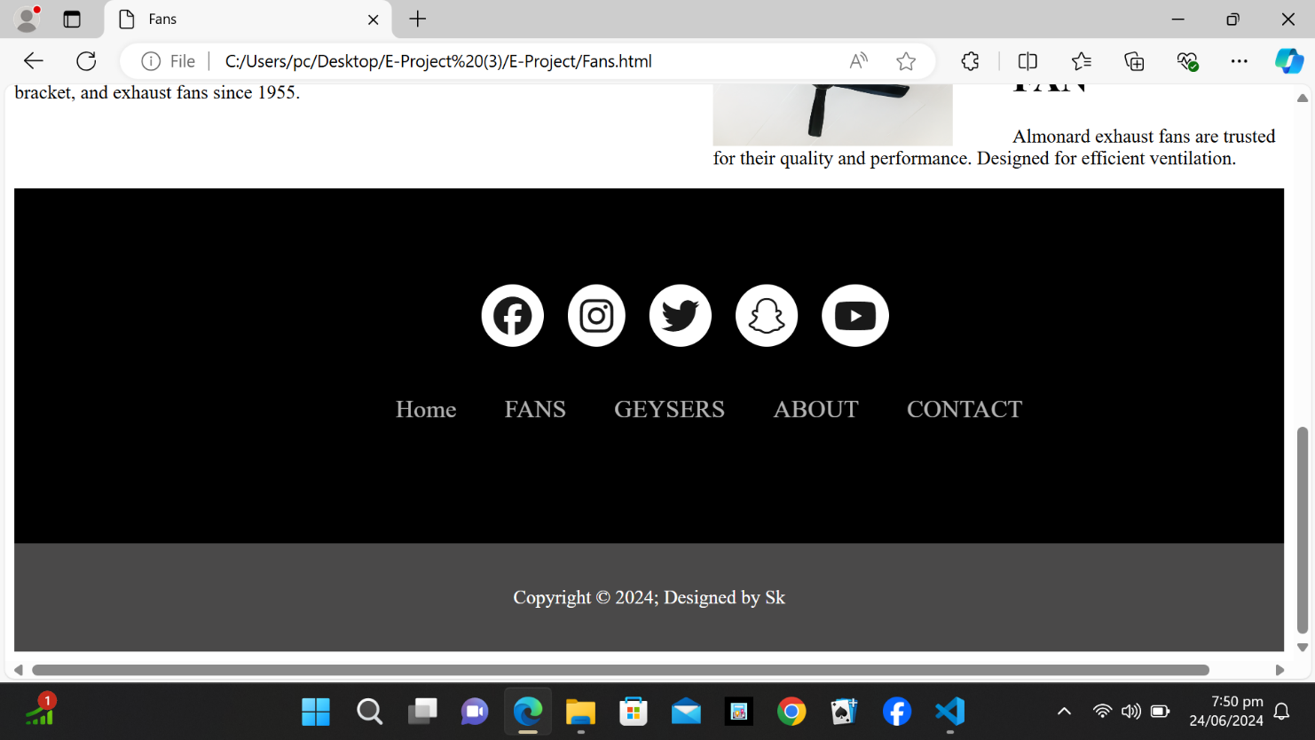

Contact us

